

TECNICATURA UNIVERSITARIA EN PROGRAMACIÓN

UNIVERSIDAD TÉCNOLOGICA NACIONAL FACULTAD REGIONAL DE GENERAL PACHECO

INGLÉS I – 2°C – 2024

**Unit 1**

# Desarrollo original y edición

Colucci Rosa María

# Colaboración

Da Silva Emiliano De Biase Mariel

Montaño Maximiliano Nuñez Paola

Vydra David

# UNIT 1

## Lesson 1 – Introducing yourself Formal and informal situations

#### Watch this video, discuss with your group mates and share with the class.

[https://drive.google.com/file/d/14o86RLGx63HAdUkD7diV8KRjWYsYEg57/view?usp](https://drive.google.com/file/d/14o86RLGx63HAdUkD7diV8KRjWYsYEg57/view?usp=drive_link)

[=drive_link](https://drive.google.com/file/d/14o86RLGx63HAdUkD7diV8KRjWYsYEg57/view?usp=drive_link)**1**

1. Who are talking? *Maria and Tom*
2. Where are they? *At de office*
3. Are they friends? How do you know? *No, because the don’t know each other*
4. Is the situation formal or informal? *It’s formal*
5. **Now watch this video, compare it with the first one, discuss with your group mates and share with the class.** [https://drive.google.com/file/d/14AJe_t3w03GR8fSoFB5YwTM9XkT1SDOo/view?us](https://drive.google.com/file/d/14AJe_t3w03GR8fSoFB5YwTM9XkT1SDOo/view?usp=drive_link) [p=drive_link](https://drive.google.com/file/d/14AJe_t3w03GR8fSoFB5YwTM9XkT1SDOo/view?usp=drive_link)**2**
6. Who are talking? *Tom and Sophie*
7. Is the situation formal or informal? *Formal*
8. What´s the difference between this situation and the first one? *In the first situation Tom introduces himself whit name and last name, and days “it’s a placer to meet you”. In the second one, he says “hi there”….*

#### These are different forms to introduce yourself according to the situation. Which do you think are formal and which are informal?

1. May I introduce myself? I’m… / Nice to meet you. I’m … FORMAL
2. Nice to meet you. I’m … / Nice to meet you too. I´m … INFORMAL

1 Source: [https://www.freecodecamp.org/learn/a2-english-for-developers/learn-greetings-in-your-first-day-at-](https://www.freecodecamp.org/learn/a2-english-for-developers/learn-greetings-in-your-first-day-at-the-office/dialogue-1-maria-introduces-herself-to-tom) [the-office/dialogue-1-maria-introduces-herself-to-tom](https://www.freecodecamp.org/learn/a2-english-for-developers/learn-greetings-in-your-first-day-at-the-office/dialogue-1-maria-introduces-herself-to-tom)

2 Source:<https://drive.google.com/file/d/14AJe_t3w03GR8fSoFB5YwTM9XkT1SDOo/view?usp=drive_link>

1. Pleased to meet you. I’m … / Glad to meet you too. I´m … FORMAL
2. How do you do? My name is… / How do you do? I´m …INFORMAL
3. It’s a pleasure to see you. I’m… / It´s a pleasure to see you too. I´m … FORMAL
4. Hello. My name is … / Hi. I’m … INFORMAL
5. I’d like to introduce myself; I’m ... / I´m glad to meet you. My name is … FORMAL
6. Let me introduce myself. I’m … / It´s a pleasure to meet you. I´m…FORMAL

#### Group work – Getting to know each other.

Introduce yourselves to your classmates in the group providing your full name.

1. **Write conversations for these situations. First, identify which are formal and which are informal. Share with your group mates.**

A  b 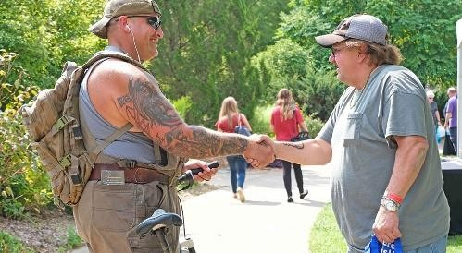 c 

d  e  f 

1. Pleased to meet you. I’m … / Glad to meet you too. I´m … FORMAL
2. How do you do? My name is… / How do you do? I´m … INFORMAL
3. Let me introduce myself. I’m … / It´s a pleasure to meet you. I´m… FORMAL
4. Hello. My name is … / Hi. I’m … INFORMAL
5. How do you do? My name is… / How do you do? I´m … INFORMAL
6. Nice to meet you. I’m … / Nice to meet you too. I´m … INFORMAL

**Personal information**

### Occupation

* 1. **Watch this video again, pay attention to the job titles and complete.** [https://drive.google.com/file/d/14AJe_t3w03GR8fSoFB5YwTM9XkT1SDOo/view?u](https://drive.google.com/file/d/14AJe_t3w03GR8fSoFB5YwTM9XkT1SDOo/view?usp=drive_link) [sp=drive_link](https://drive.google.com/file/d/14AJe_t3w03GR8fSoFB5YwTM9XkT1SDOo/view?usp=drive_link)**3**

***Tom****: I´m Tom. I´m the …Graphic Designer*

***Sophie****: I´m Sophie. I´m a … Developer*

### Happy Face Emoticon Stock Illustrations – 154,845 Happy Face Emoticon Stock Illustrations, Vectors & Clipart - Dreamstime Articles

When we talk about our job titles, we can use the definite article “**the**” or the indefinite articles “**a**” or “**an**”.

The definite article is used when there is only one person who holds that position in the company. It is used with the singular or plural forms, with any gender and with job titles that start with any letter of the alphabet.

* *I´m* ***the*** *CEO.*
* *I´m* ***the*** *team lead.*

The indefinite articles are used with the singular forms and with any gender. But there is a difference between “**a**” and “**an**”. “**A**” is used before words that start with a consonant and “**an**” with words that start with a vowel sound.

* *I´m* ***a*** *graphic designer.*
* *I´m* ***an*** IT Technician.

3 Source: [https://www.freecodecamp.org/learn/a2-english-for-developers/learn-greetings-in-your-first-day-at-](https://www.freecodecamp.org/learn/a2-english-for-developers/learn-greetings-in-your-first-day-at-the-office/dialogue-2-tom-meets-the-coworker-next-to-him) [the-office/dialogue-2-tom-meets-the-coworker-next-to-him](https://www.freecodecamp.org/learn/a2-english-for-developers/learn-greetings-in-your-first-day-at-the-office/dialogue-2-tom-meets-the-coworker-next-to-him)

### Happy Face Emoticon Stock Illustrations – 154,845 Happy Face Emoticon Stock Illustrations, Vectors & Clipart - Dreamstime Job titles connected with your area of expertise

Game programmer Web Developer Mobile app developer Computer programmer Data Scientist

IT Technician Systems Analyst

Cybersecurity software developer Database Administrator

Front-end Developer Software developer Graphic designer Team lead

Team member CEO

**Levels of Developers / Programmers** Level 1: Trainee Developer / Programmer Level 2: Junior Developer / Programmer

Level 3: Semi Senior Developer / Programmer Level 4: Senior Developer / Programmer Level 5: Leader

* 1. **Group work – Roleplay Situation** – My first day at work

One of you is new at an international company, introduce yourself providing your full

name and your new position in the company. The rest of the group work for the company, introduce yourselves providing full name and position. You can decide if the situation is formal or informal.

 **Remember!**

|  |
| --- |
| **Job title + company** |
| I´m + **a/an/the** + job title + **at** + company. |
| *I´m* ***the*** *Database Administrator* ***at*** *Ford.* |

## Origin and nationality

1. **Watch this video and complete.** [https://drive.google.com/file/d/1DPvUbEk21ihhbLwZIsGG9G8V-](https://drive.google.com/file/d/1DPvUbEk21ihhbLwZIsGG9G8V-lts935f/view?usp=drive_link) [lts935f/view?usp=drive_link](https://drive.google.com/file/d/1DPvUbEk21ihhbLwZIsGG9G8V-lts935f/view?usp=drive_link)**4**

***Sophie****: Where are you from, Tom?*

***Tom****: I´m from …How about you? Texas*

***Sophie****: I´m from ... here California*

#### Now pay attention to the table below. What nationality are Tom and Sophie?

|  |  |
| --- | --- |
| **Country** | **Nationality** |
| Argentina | Argentinian |
| Brazil | Brazilian |
| Bolivia | Bolivian |
| Chile | Chilean |
| China | Chinese |
| Colombia | Colombian |
| England | English |
| France | French |
| Panama | Panamanian |
| Peru | Peruvian |
| United States | (North) American |
| Venezuela | Venezuelan |
| Uruguay | Uruguayan |

4 Source: [https://www.freecodecamp.org/learn/a2-english-for-developers/learn-greetings-in-your-first-day-at-](https://www.freecodecamp.org/learn/a2-english-for-developers/learn-greetings-in-your-first-day-at-the-office/dialogue-2-tom-meets-the-coworker-next-to-him) [the-office/dialogue-2-tom-meets-the-coworker-next-to-him](https://www.freecodecamp.org/learn/a2-english-for-developers/learn-greetings-in-your-first-day-at-the-office/dialogue-2-tom-meets-the-coworker-next-to-him)

#### Group work – What nationality are you?

Tell your group mates about your place of origin and your nationality.

**Remember!**

|  |  |
| --- | --- |
| **Origin** | **Nationality** |
| I´m + **from** + city/country. | I´m + nationality. |

#### Texto Descripción generada automáticamenteGroup work – Roleplay

**Situation** – You are at the SAP Sapphire & ASUG Annual Conference in Orlando5 and you meet people from other countries. Choose one of the persons in the grid, introduce yourself at the event, provide your full name, your position in your company and your place of origin. Roleplay the situation with the information in the grid below.

|  |  |  |  |
| --- | --- | --- | --- |
| **Full name** | **Job title** | **Company** | **Origin** |
| Joe / Alice Adams | IT Technician |  | London |
| Ana / Elena Castillo | CEO |  | Panamá City |
| Dominique / Philip Bernarde | Trainee Developer |  | Paris |
| José / Susana Ramirez | Database Administrator |  | Bogotá |
| Miguel / Carlos de Souza | Graphic designer |  | Río de Janeiro |

5 Source: <https://www.sap.com/latinamerica/events/sapphire/orlando.html>

|  |  |  |  |
| --- | --- | --- | --- |
| Helen / Robert Williams | Mobile app developer |  | Florida |

#### Choose one of these companies in Activity 4 and copy information about it (not more than 60 words).

**Torus Systems is an expert company in technological solutions. It is located in the city of Bogotá, Colombia, and has more than 15 years of experience. The services they offer include cybersecurity, internet browsing control, secure remote connections, data backup, enterprise networks, management and support services, and security and compliance consulting.**

1.  **Read the announcement from** *SAP Sapphire & ASUG Annual Conference in Orlando* **and do the activities.**

## Lesson 2 – Introducing others

1. **Watch this video, discuss with your group mates and share with the class.** [https://drive.google.com/file/d/16ZSvAlChhyXiUMMgNCQGHVOOIzJXtC8Q/view?us](https://drive.google.com/file/d/16ZSvAlChhyXiUMMgNCQGHVOOIzJXtC8Q/view?usp=drive_link) [p=drive_link](https://drive.google.com/file/d/16ZSvAlChhyXiUMMgNCQGHVOOIzJXtC8Q/view?usp=drive_link)**6**

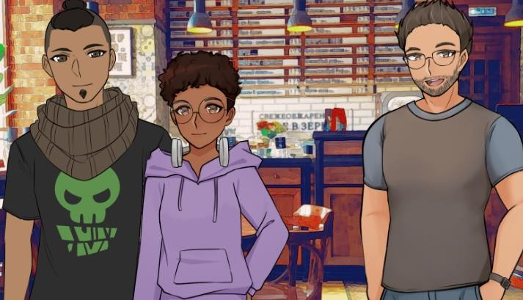

* 1. How many people are talking?
  2. Do they know each other?
  3. Is the situation formal or informal? How do you know?

#### Watch the video again and complete what Sophie and Brian say.

**Sophie***: … , let me introduce you to … . …, this is …. He´s a web developer.*

**Brian***: It´s a , Tom!*

#### These are different forms to introduce other people according to the situation. Which do you think are formal and which are informal?

* 1. **Ann**: Betty, may I introduce you to Alan? Alan, this is Betty.

**Betty**: Hi, Alan, nice to meet you.

* 1. **Ivy**: George, it’s a pleasure to introduce you to Lucas. Lucas, this is George.

**George**: Pleased to meet you.

* 1. **Angel**: Teresa, I’d like to introduce you to Alice. Alice, this is Teresa.

**Teresa**: I´m glad to meet you, Alice.

* 1. **William**: Let me introduce you to Alex. Alex, this is Jack.

**Jack**: It´s a pleasure to meet you, Alex.

6 Source: [https://www.freecodecamp.org/learn/a2-english-for-developers/learn-greetings-in-your-first-day-at-](https://www.freecodecamp.org/learn/a2-english-for-developers/learn-greetings-in-your-first-day-at-the-office/dialogue-4-sophie-introduces-brian-to-tom) [the-office/dialogue-4-sophie-introduces-brian-to-tom](https://www.freecodecamp.org/learn/a2-english-for-developers/learn-greetings-in-your-first-day-at-the-office/dialogue-4-sophie-introduces-brian-to-tom)

**Personal pronouns**

When you introduce yourself and provide your name, your position in your company or your country of origin, you always use the pronoun **“I”**. And when you introduce and provide information about another person, you can use **“he”** or **“she”.** If you want to use inclusive language, you can use **“they”.**

* ***He****´s a web developer.* ***He****´s our new graphic designer and* ***he****´s from Texas.*
* ***She****´s Italian and* ***she****´s from Rome.*
* ***They****´re the web developers.* ***They****´re from the United Kingdom.*

#### Complete these conversations.

**Bob**: Alison, let … … you … Robert. Robert, … … Alison. … the team leader.

**Alison**: Pleased … … you, Robert.

**Robert**: Glad to … … …, Alison.

**Muriel**: Adrian, I´d like … … you to Bill. Bill, … is Adrian. … a junior programmer.

**Adrian**: I´m glad … … … .

**Bill**: Nice too!

**Vivian**: Bill, this … Oliver. Oliver, … is Bill. … a front-end developer.

**Bill**: Hello, Oliver.

**Oliver**: …, … .

**Evelyn**: Noha, it’s a pleasure … … … … James. James, … … Noha.

… a graphic designer.

**Noah**: Nice you.

**James**: It´s a … to … you, ….

#### Group work – Roleplay



**Situation –** You are at the Uxin event in Buenos Aires7 with two university partners. You meet people at the event. Introduce yourself, provide your full name and your position in your company and introduce your partners.

# Describing people

1. **Watch this video and complete what Brian says about Sophie** [https://drive.google.com/file/d/1IJtN4ZkDxHIekQhi-](https://drive.google.com/file/d/1IJtN4ZkDxHIekQhi-A7dVTJKKJryJJur/view?usp=drive_link) [A7dVTJKKJryJJur/view?usp=drive_link](https://drive.google.com/file/d/1IJtN4ZkDxHIekQhi-A7dVTJKKJryJJur/view?usp=drive_link)**8**

#### Choose from the personality traits in the grid.

|  |  |  |  |  |  |  |  |
| --- | --- | --- | --- | --- | --- | --- | --- |
| cheerful | a generous colleague | funny | optimistic | reliable | an  adaptable coworker | bright | a great worker |
| a helpful partner | hard- working | curious | an honest assistant | confident | good- humoured | kind | savvy |

**Brian**: *Sophie is a … . She´s very … and … .*

**Remember!**

|  |  |  |  |  |  |  |
| --- | --- | --- | --- | --- | --- | --- |
| I am He/She is | a/an | ambitious (adjective) | employee. (noun) |  | I am He/She is | patient. (adjective) |

7 Source: [https://allevents.in/buenos%20aires/uxin-%7C-mr-and-mrs-smith-of-software-](https://allevents.in/buenos%20aires/uxin-%7C-mr-and-mrs-smith-of-software-development/10000870484381217) [development/10000870484381217](https://allevents.in/buenos%20aires/uxin-%7C-mr-and-mrs-smith-of-software-development/10000870484381217)

8 Source: [https://www.freecodecamp.org/learn/a2-english-for-developers/learn-greetings-in-your-first-day-at-](https://www.freecodecamp.org/learn/a2-english-for-developers/learn-greetings-in-your-first-day-at-the-office/dialogue-4-sophie-introduces-brian-to-tom) [the-office/dialogue-4-sophie-introduces-brian-to-tom](https://www.freecodecamp.org/learn/a2-english-for-developers/learn-greetings-in-your-first-day-at-the-office/dialogue-4-sophie-introduces-brian-to-tom)

#### Group work

**Now describe yourself with the personality traits in the grid.**

#### Think of names, nationalities, job titles, companies, and personal traits, and complete the information in the grid.

|  |  |  |  |  |
| --- | --- | --- | --- | --- |
| **Full names** | **Nationalities** | **Job titles** | **Companies** | **Personality traits** |
|  |  |  |  |  |
|  |  |  |  |  |
|  |  |  |  |  |
|  |  |  |  |  |
|  |  |  |  |  |
|  |  |  |  |  |

1. **Group work**

#### Look at the people in the pictures and describe them with the information in the grid above.

a b  c 

d  e  f 

#### Look at the people in the pictures again and write the descriptions. Then share them with your group partners.

**Here is an example:** *This is Michelle Alons. He is French. He is a mobile app developer at Samsung. He is an excellent partner, and he is very funny.*

1. **Watch this video and do the activities.**

[https://www.youtube.com/watch?v=71yKCb1YKMA&ab_channel=TalkingHeadsLan](https://www.youtube.com/watch?v=71yKCb1YKMA&ab_channel=TalkingHeadsLanguageServices) [guageServices](https://www.youtube.com/watch?v=71yKCb1YKMA&ab_channel=TalkingHeadsLanguageServices)

# Education

### Current studies

Alfonso is from the IE University**9** in Spain. He is introducing himself.

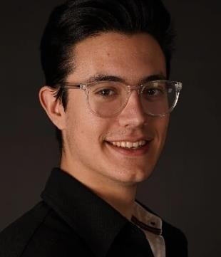*I´m Alfonso José Pérez López. I´m from Murcia, Spain, and I´m currently studying Business Administration and International Relations.*

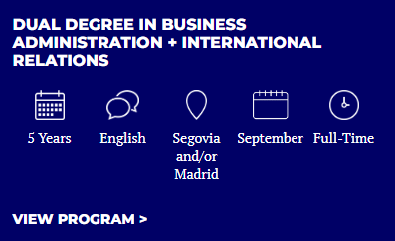

### Thinking Emoji Images – Browse 12,886 Stock Photos, Vectors ...Remember!

The Present Continuous Tense is used for activities that are in progress while we speak about them. “Now”, “currently” or “at the moment” are phrases used with this tense.

|  |  |  |
| --- | --- | --- |
| Person | am/is/are | verb+ing |

#### Group work

**Can you introduce yourself?**

*I’m … . I´m from… , and I´m … a university degree in programming at the National Technological University in General Pacheco.*

9 Source: [https://landings.ie.edu/schoolland-ie-university-en-](https://landings.ie.edu/schoolland-ie-university-en-cro?gclsrc=aw.ds&gad_source=1&gclid=CjwKCAjwrcKxBhBMEiwAIVF8rEzLTeZc008W6HsT24EykHfQgR2OP9bPiRRrkZS1dM1E9PtAGivtBhoCN_EQAvD_BwE) [cro?gclsrc=aw.ds&gad_source=1&gclid=CjwKCAjwrcKxBhBMEiwAIVF8rEzLTeZc008W6HsT24EykHfQgR2O](https://landings.ie.edu/schoolland-ie-university-en-cro?gclsrc=aw.ds&gad_source=1&gclid=CjwKCAjwrcKxBhBMEiwAIVF8rEzLTeZc008W6HsT24EykHfQgR2OP9bPiRRrkZS1dM1E9PtAGivtBhoCN_EQAvD_BwE) [P9bPiRRrkZS1dM1E9PtAGivtBhoCN_EQAvD_BwE](https://landings.ie.edu/schoolland-ie-university-en-cro?gclsrc=aw.ds&gad_source=1&gclid=CjwKCAjwrcKxBhBMEiwAIVF8rEzLTeZc008W6HsT24EykHfQgR2OP9bPiRRrkZS1dM1E9PtAGivtBhoCN_EQAvD_BwE)

#### The UTN in General Pacheco also offers different courses. Are you doing any of these or are you doing another course? Can you tell us?

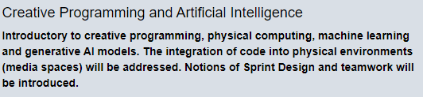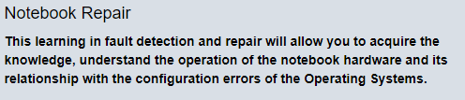

* 1. **The people in the pictures are students at the IE University too. Can you describe them? Complete the sentences and share with your group mates.**



a. David Salinas – Bolivia b. Susan Miller – Germany c. Nathan Gautier – France

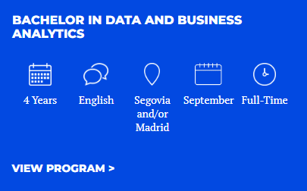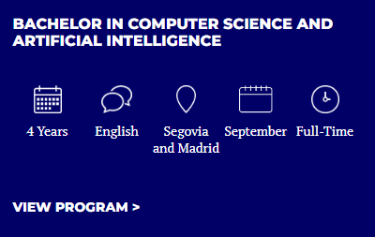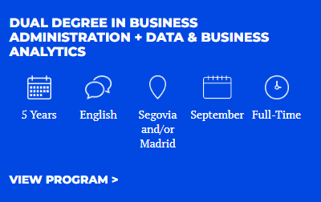

1. David …
2. Susan …
3. Nathan …

# Interests

#### Alfonso also talks about his interests in his introduction.

*Outside of university, I enjoy laughing with my friends and making time to centre myself. I like connecting with nature and practising yoga. In addition to my studies, I sing in a choir and organize events, including a recital featuring a world-renowned pianist.*

#### Can you complete these sentences with his interests?

* 1. I enjoy …
  2. I like …
  3. I sing …
  4. I organize …

 **verb+ing**

The verbs ***like****,* ***enjoy*** or ***love*** are used to indicate how you feel about an activity. These verbs are followed by a verb in the **“ing form”.**

* *I* ***like wearing*** *casual clothes at work.*
* *I* ***enjoy chatting*** *with friends.*
* *I* ***love telling*** *jokes.*

#### What are your interests? Can you tick them off? You can add some more if you want to.

|  |  |  |  |
| --- | --- | --- | --- |
| walk my dog | play football | watch films/series | do workouts |
| visit friends | cycle | read the news online | play video games |
| run | listen to music | surf the internet | go to the cinema |
| check social media accounts | spend time with my family | chat with my friends | meet friends for a beer |
|  |  |  |  |
|  |  |  |  |

1. **Group work**

**Tell your mates about your interests. After that, write them down. Examples:** *I enjoy listening to pop music and to classical music, too.*

*I love meeting friends.*

*I like running or cycling.*

### Happy Face Emoticon Stock Illustrations – 154,845 Happy Face Emoticon Stock Illustrations, Vectors & Clipart - Dreamstime Simple Present Tense

In English, the Simple Present is used for actions we regularly do, or we don´t do, for habits and permanent situations. When we refer to permanent states, we mean situations or feelings which are not temporary, for example, our interests.

#### How to form the Simple Present

|  |  |
| --- | --- |
| **3rd person singular (he/she/it)** | **Other forms (I/you/we/they)** |
| AFFIRMATIVE – verb+**s** / verb+**es** | AFFIRMATIVE – verb |
| *Alice love****s*** *sleeping late on Sundays.* | *I* ***sing*** *in a choir and* ***organize*** *events.* |
| *Billy watch****es*** *series in Netflix.* | *We* ***enjoy*** *meeting friends at weekends.* |
| NEGATIVE – **doesn´t** + verb | NEGATIVE – **don´t** + verb |
| *Peter* ***doesn´t*** *like running.* | *I* ***don****´t watch films during the day.* |
| *My friend* ***doesn´t*** *practise yoga.* | *Susy and Lily* ***don****´t like organizing parties.* |

1. **Group work**

#### Pay attention to the grid above and tell your mates about your family´s and friend´s interests.

1. **Group work**

#### Now compare your interests to your family´s or friend´s interests. After that write them down.

**Examples:**

*I enjoy listening to pop music* ***and*** *my sister enjoys listening to pop music, too. I love meeting friends,* ***but*** *my friends don´t like going to bars.*

*I like running and cycling,* ***but*** *my mum doesn´t like running* ***or*** *cycling.*

#### Look at the pictures and complete these people´s interests.

a) 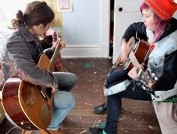 Edith and Betty …

b) 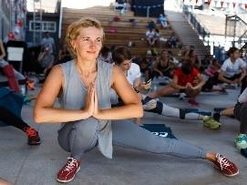 Marcel …

c) Alan and Cecil …

d)  Elizabeth …

e) 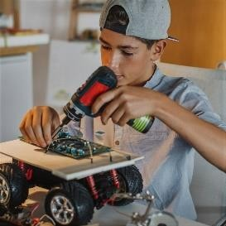 Brandon …

**Let´s talk about your partner!**

**Sustained monologue**

#### Pair work

* 1. First, take turns to introduce yourself to your partner. Include these items: occupation, origin and nationality, personal traits, studies, interests, and work routines. (If necessary, take notes of what your partner tells you.)
  2. Then, change pairs and tell your new partner about your previous partner.

1.  **Record your monologue about your partner in MP3 and upload it to the Moodle room.**

## Lesson 3 - Work routines

This is Abhishek Bhardwaj10. He is from India. He is a Machine Learning Engineer and a web developer at AWS.



**1. , a social question-and-answer website, has asked him a question: *“As a web developer, what is your daily routine and working hours?”*. Look at the article and complete his answer.**

*I generally start my day at 5 AM. So here is my routine as a programmer excluding weekends. At 5 AM I write … and do … At 7 AM I get … At 9:30 AM I reach …, have*

*… and talk … At 10 AM I have … and discuss … From 10 AM to 2 PM I work with … At 2 PM I have … From 3 PM to 6 PM I work with … again. At 6 PM I log …*

10 Source: <https://www.linkedin.com/in/abhiai/>

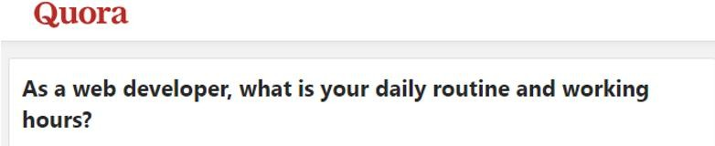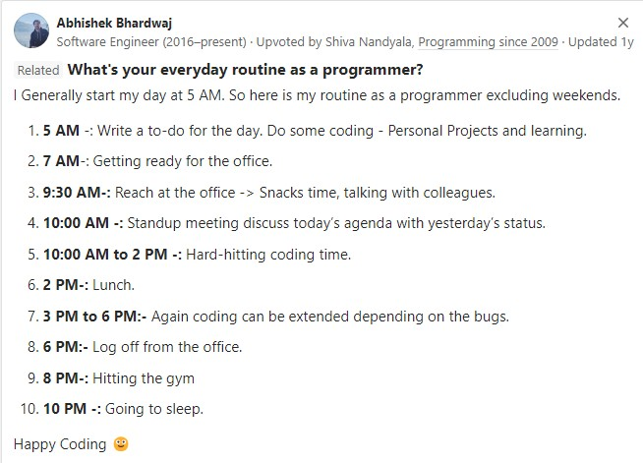

[**https://www.quora.com/As-a-web-developer-what-is-your-daily-routine-and-working-hours**](https://www.quora.com/As-a-web-developer-what-is-your-daily-routine-and-working-hours)

A **stand-up meeting** (stum) is a [meeting](https://en.wikipedia.org/wiki/Meeting) in which attendees typically participate while [standing.](https://en.wikipedia.org/wiki/Standing) The discomfort of standing for long periods is intended to keep the meetings short. (From Wikipedia, the free encyclopaedia)

### Thinking Emoji Images – Browse 12,886 Stock Photos, Vectors ...Remember!

The Simpe Present is used for regular activities.

* *I* ***hit****11* *the gym at 8 PM.*
* *I* ***go*** *to sleep at 10 PM.*

11 Hit the gym: go to the gym to exercise, also hit workouts.

### Happy Face Emoticon Stock Illustrations – 154,845 Happy Face Emoticon Stock Illustrations, Vectors & Clipart - DreamstimeAdverbs of frequency

The adverbs of frequency describe how often we do things. We place these adverbs before the main verb, or at the beginning of the sentence, but we always place them after the verb “be”.

* *I* ***generally*** *start my day at 5 PM. /* ***Generally,*** *I start my day at 5 PM.*
* *I am* ***always*** *in the office in the morning.*

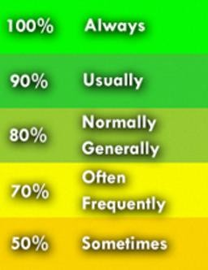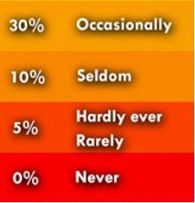



When we want to be more specific about frequency, we can use these expressions: **every day/month, every other week, once a week/month, twice a day/year, three/four times a week**.

#### Which of these actions are part of your daily routine? Can you tick them off? If necessary, add some more actions.

|  |  |  |  |
| --- | --- | --- | --- |
| read emails | restart project work | fix appointments | speak to the team leader |
| review achievements | call clients | make a schedule for the day | report the progress |
| list down ongoing tasks | take a break | do project work | reply to emails |
|  |  |  |  |

1. **Pair work – Roleplay**

**Situation - ** asks you the question *“What is your daily routine and working hours?”*. Pay attention to Bhardwaj´s answer and tell your partner about your work routine. If you don´t have a job at the moment, you can add some daily routines to the grid and talk about them. Remember to include frequency adverbs and the time you do those actions.

**You can start like this:** *I generally start my day at …*

#### 4. is going to publish your answer, so considering your choices, write a paragraph to answer the question.

*I generally start my day at …*…………………………………………………………….

………………………………………………………………………………………………

………………………………………………………………………………………………

………………………………………………………………………………………………

…………………………………….…………………………………………………………

**5. Read about Pam´s work routines and do the activities.**

## Social media profiles

#### Let´s examine again the introduction to Abhishek Bhardwaj´s profile in , a business and employment-focused social media platform.



1. **Before reading, find out what these acronyms stand for.**
   1. NLP …
   2. LLM …
   3. MLOps …

#### Now read the profile, tick the items that have been included and complete the information.

|  |  |
| --- | --- |
| Interests |  |
| Personal traits |  |
| Name |  |
| Work routines |  |
| Place of residence |  |
| Job title |  |
| Origin / Nationality |  |
| Current workplace |  |
| Education |  |
| Skills |  |
| Other information |  |

1. **This is Ajay Yadav´s profile in ** **12****. Before you read it, discuss with your mates.**
   1. What does “first-gen” stand for?
   2. What´s the meaning of “angel investor”?
   3. What is ?
   4. Why is it mentioned in the profile?

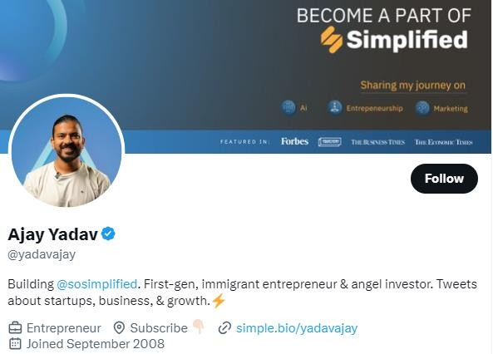

#### What information does this profile include? Complete the grid. Mention the items and provide the details.

|  |  |
| --- | --- |
| **Items** | **Details** |
| Name | Ajay Yadav |
|  |  |
|  |  |
|  |  |

12 Source: <https://twitter.com/yadavajay?lang=en>

#### You are going to write the introduction to your profile for a social media, but first decide what you are going to include and collect the information in this grid.

|  |  |
| --- | --- |
| Name |  |
| Education |  |
| Job title |  |
| Interests |  |
| Skills |  |
| Personal traits |  |
| Place of residence |  |
| Current workplace |  |
| Other information |  |

1.  **Write the introduction to your profile for a social media. First, choose a social media and find a template to give it shape. Complete it and upload it to the Moodle room. If you are not working at the moment, omit job title and current workplace.**

## Lesson 4 - Requesting for personal information

#### In certain situations, you may have to answer personal questions. Can you make a list of these situations? If you don´t know them in English, ask your teacher.

**Example**: at the postal office when you pick up a package

|  |
| --- |
|  |
|  |
|  |
|  |
|  |
|  |

#### These are some of the possible questions that you may need to answer. Can you answer them?

|  |  |
| --- | --- |
| What´s your name? |  |
| Can you spell it?13 |  |
| Where are you from? |  |
| What´s your nationality? |  |
| Where do you live? |  |
| What´s your address? |  |
| What´s your telephone number? |  |
| What´s your job? |  |

13 How to read the alphabet <https://www.youtube.com/watch?v=X15lZVm1KP8&ab_channel=ENGLISHWITHAL>

|  |  |
| --- | --- |
| Where do you work? |  |
| What are you studying? |  |
| What are you interested in? |  |
| Do you work from home? |  |
| How often do you go to the office? |  |

**Remember!**

#### Address in English

house number + street name14 + apartment number

* + 3425 Stone Street, Apt.15 2A
    - 145 Giggle Ave

#### Group work

Pay attention to the list of situations in Activity 2 and roleplay them. Choose the right questions for each context. Try to remember how each question is structured.

#### Writing – Pair work

Choose one of the situations and write the conversation.

1. **Watch this video and complete the information in the grid.** [**https://drive.google.com/file/d/1KEOSCIH4HM6tsKGQToOvS26L7bnOKfMG/**](https://drive.google.com/file/d/1KEOSCIH4HM6tsKGQToOvS26L7bnOKfMG/view?usp=drive_link)[**view?usp=drive_link**](https://drive.google.com/file/d/1KEOSCIH4HM6tsKGQToOvS26L7bnOKfMG/view?usp=drive_link)**16**

14 Different abbreviations for your address: “St.” for Street, “Ave.” for Avenue, “Rd.” for Road, “Blvd” for Boulevard.

15 Apt. = apartment

16 Source: <https://www.youtube.com/watch?v=kbRK5KSXLbw&ab_channel=EnglishBeyondtheClassroomUQ>

|  |  |
| --- | --- |
| Name of the course |  |
| Applicant´s full name |  |
| Applicant´s address |  |
| Applicant´s zip code |  |
| Applicant´s telephone  number |  |
| Payment options |  |

## How to expand your social media profile

The first section in a  profile is **About**. In this part, you can expand what you have anticipated in the introduction.

#### What information in Abhishek Bhardwaj´s profile has been expanded in his

***About* section? Complete the grid below.**

|  |  |
| --- | --- |
| **Items** | **Details** |
|  |  |
|  |  |
|  |  |
|  |  |
|  |  |
|  |  |

**About**

Abhishek Bhardwaj is a Sr. Data and Machine Learning Engineer at Amazon Web Services (AWS). He is AWS and deeplearning.ai certified and has a master´s degree in computational decision science from the Illinois Institute of Technology Chicago. He is passionate about solving problems and designing scalable machine learning pipelines17.

17 Adapted from <https://www.linkedin.com/in/abhiai/>

**Remember!**

* **have/ has** + a + master´s degree + **in** + … + **from** + the + name of university/institute

*He has a master´s degree in computational decision science from the Illinois Institute of Technology Chicago.*

* + is/are/am + passionate about + **verb+ing**

*He is passionate about solv****ing*** *problems and design****ing*** *…*

#### This is Julien Simon18, read his profile and complete the grid with information from the introduction and from the *About* section.

|  |  |
| --- | --- |
| Name |  |
| Job title |  |
| Current  workplace |  |
| Education |  |
| Interests |  |
| Origin |  |

18 Source: <https://www.linkedin.com/in/juliensimon/>

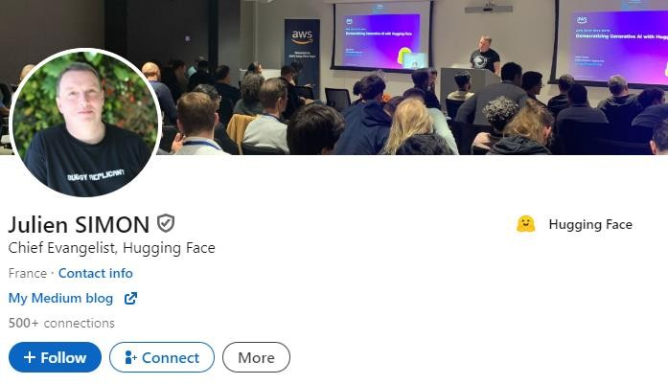

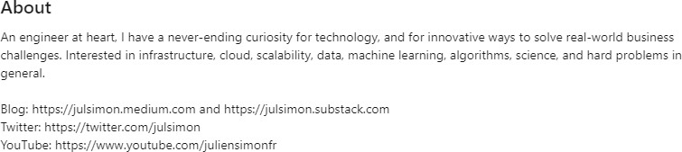

1. **Now, let´s go back to your profile. What information can you add in the *About* section? Decide what you are going to include and collect the information in the grid below.**

|  |  |
| --- | --- |
| **Item** | **Details** |
|  |  |
|  |  |
|  |  |
|  |  |
|  |  |
|  |  |

## How to expand your social media profile (continued)

There are also other sections in a  profile, two of them are **Experience** and

#### Education.

1. **What facts does Bhardwaj include in the *Experience section*? Which items are present? Tick them off.**
   1. Education
   2. Current workplace
   3. Interests
   4. Responsibilities
   5. Number of working hours
   6. Current activities
   7. Dates
   8. Job title

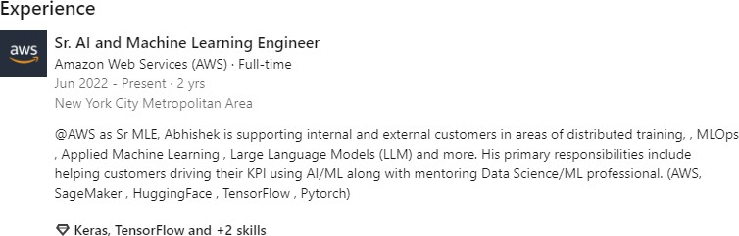

**Remember!**

* + - My/his/her responsibilities include + **verb+ing**

*His primary responsibilities include* ***helping*** *customers …*

#### In the *Education section*, Bhardwaj adds information about the educational institutions where he studied, his degrees and the dates when he started and finished his studies.

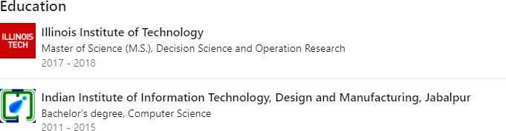

1.  **Let´s complete your profile. Write the *About*, the *Experience* and *Education* sections and add them to the Introduction. Then upload your complete profile to the Moodle room.**